JENKINS PROJECTS FREESTYLE

**Jenkins:**

**Jenkin installation**

**Os-ubuntu:**

Step1:

**Java installation**

**Jdk:**



**Jenkin installation:**

**Enable and Start the Jenkins :**

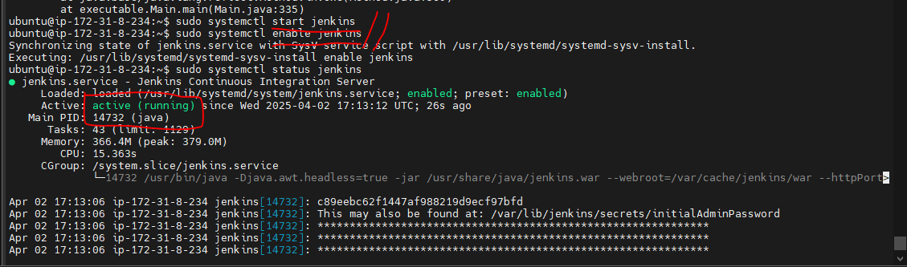

**Step2**:

**LOGIN JENKINS:**

Go to browser put public ip address with 8080 port number default

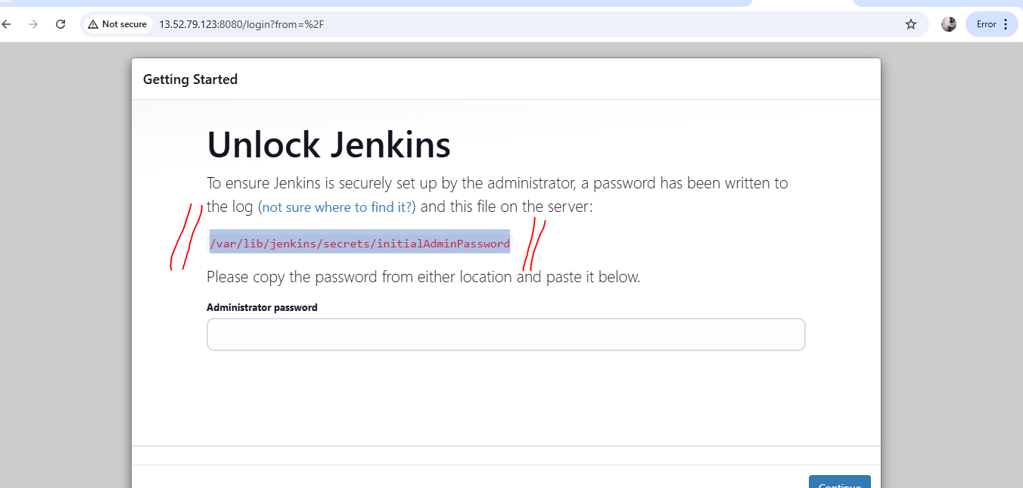

How to get the Administrator Password :

Copy the path go to machine using cat command to get the code:

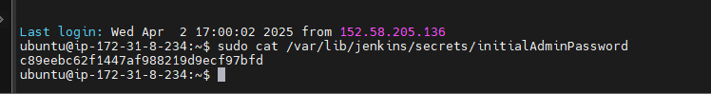

**Configuration:**

Set the username and password (own)

**Plugin installations:**

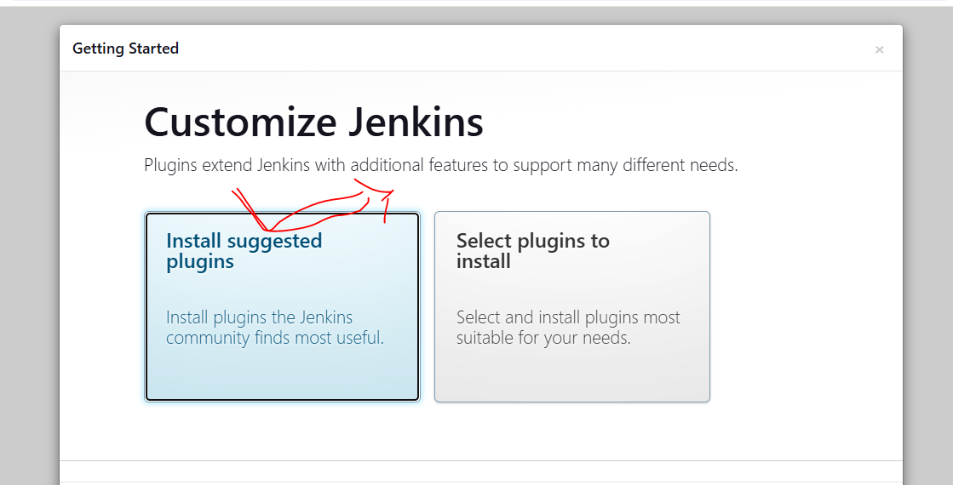

**After completing the installation, you have to moved to set username and password :**

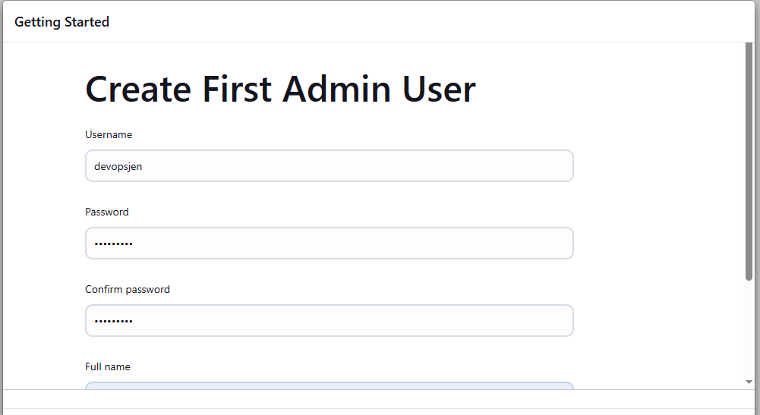

URL: [http://youripadress:8080/](http://13.52.79.123:8080/)

ready to use the jenkins

Finally get Jenkin job page:

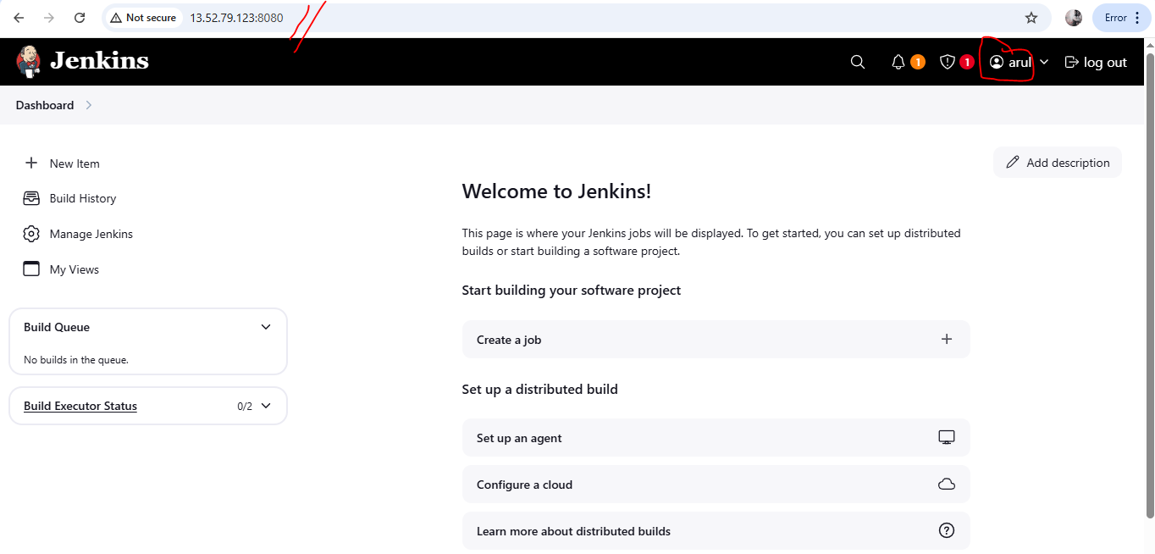

INSTALLATION AND CONFIGURATION COMPLETED

**Project creation:**

**Freestyle: without scm**

**i have to create the free style project based on the below mentioned steps:**

**Got to Jenkins DASHBOARD**

**Select newitem**

**name: freesteyle**

**Select the which type of project: freestyle**

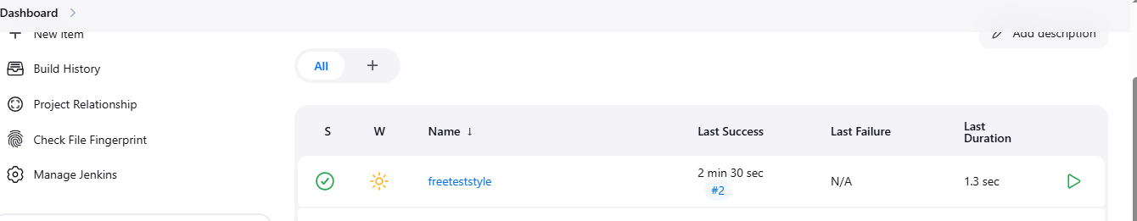

**Select the freestyle project go to Configure**

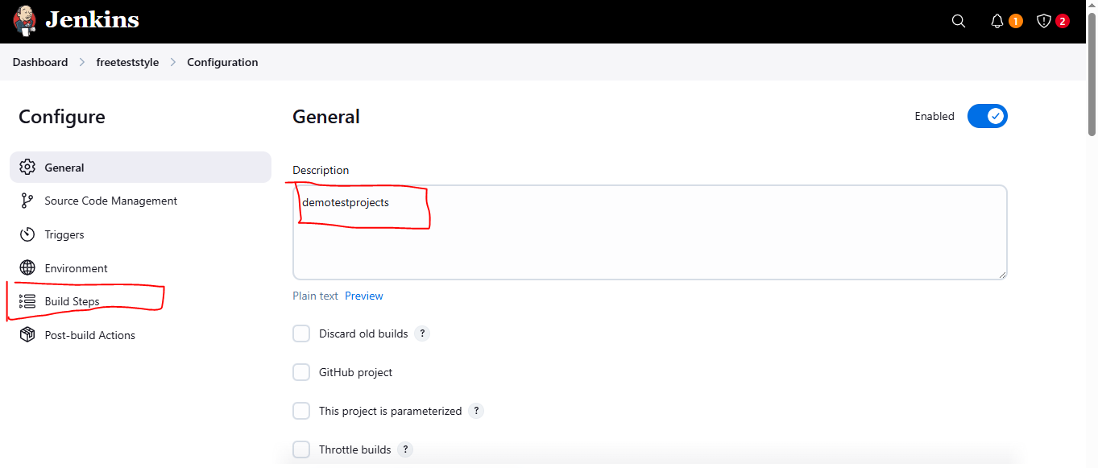

**First i have to write the Description (project name) then got to Buildsteps**

**In the Buildsteps I add the Buildsteps ---- choose the ExecuteShell and write code(java pgm “hellow world”)**

**Program:**

**echo "Creating HelloWorld.java..."**

**cat > HelloWorld.java <<EOF**

**public class HelloWorld {**

**public static void main(String[] args) {**

**System.out.println("Hello, World from Jenkins on Linux!");**

**}**

**}**

**EOF**

**echo "Compiling Java program..."**

**javac HelloWorld.java**

**echo "Running Java program..."**

**java HelloWorld**

**images:**

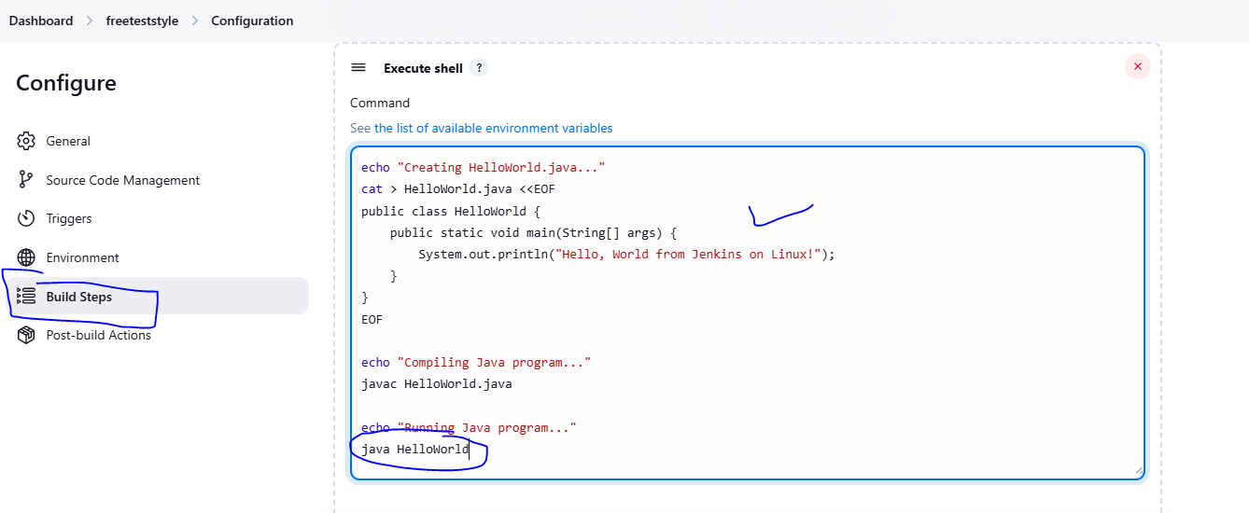

**Apply and Save the configuration**

**Build the Jenkins Job:**

**Run a job click the Buildnow**

**It will take a time to run a program to execute the result**

**This is the build for freestyle job jenkins** 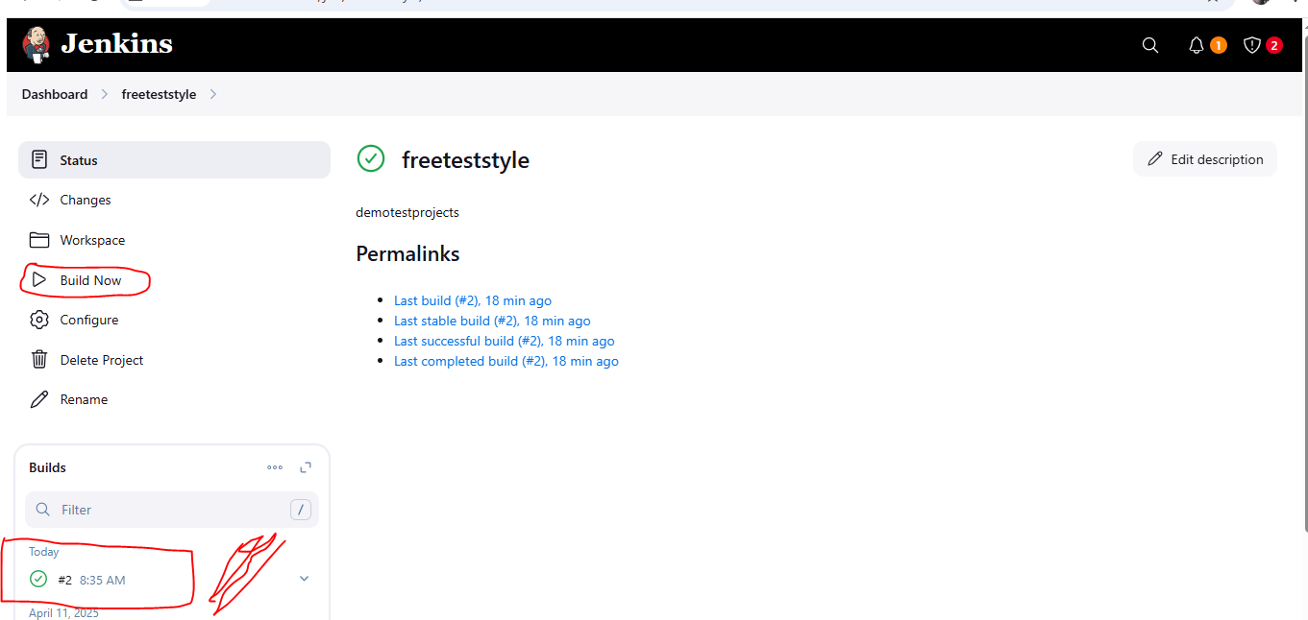

**Check the output:**

**Finally get the build success for project**

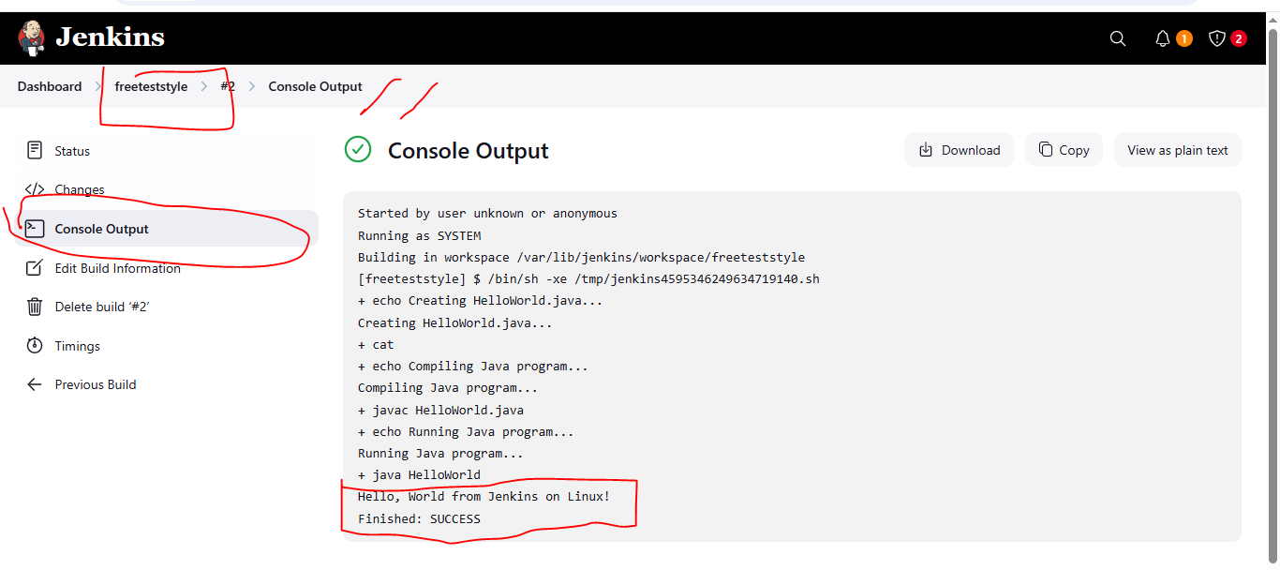

**Project:freestyle2**

**Create Jenkins frestyle to Automatic Deployment of JAVA Application on Tomcat Serve**r

**Configuration:**

**Steps:**

**scm**

**add**

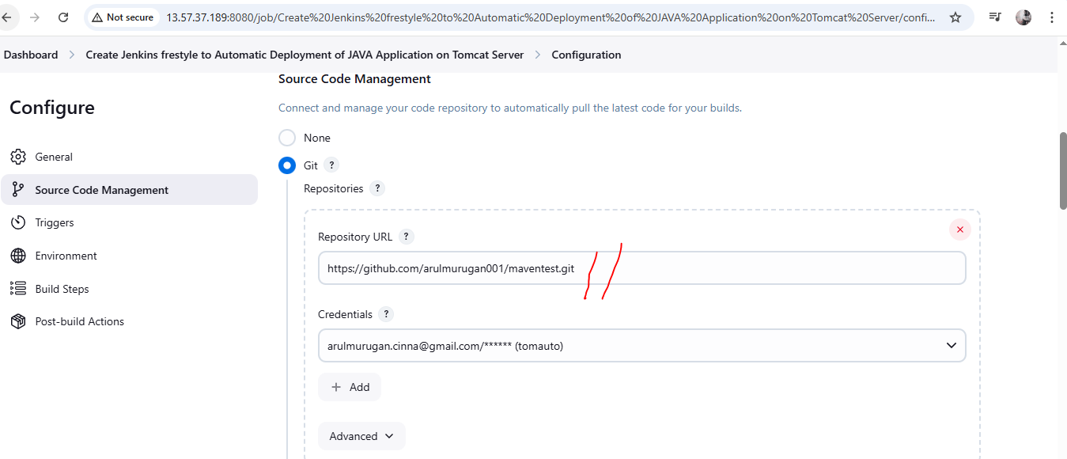

Build Steps

Maven add:

Clean and package

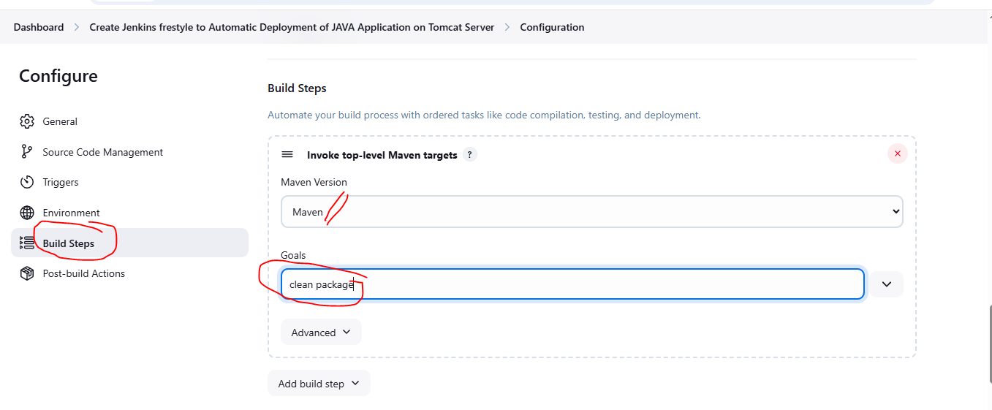

**Post-build Actions steps:**

**url and tomacat container add:**

**we have to add the correct war file extension and contextpath name & container save an dapply**

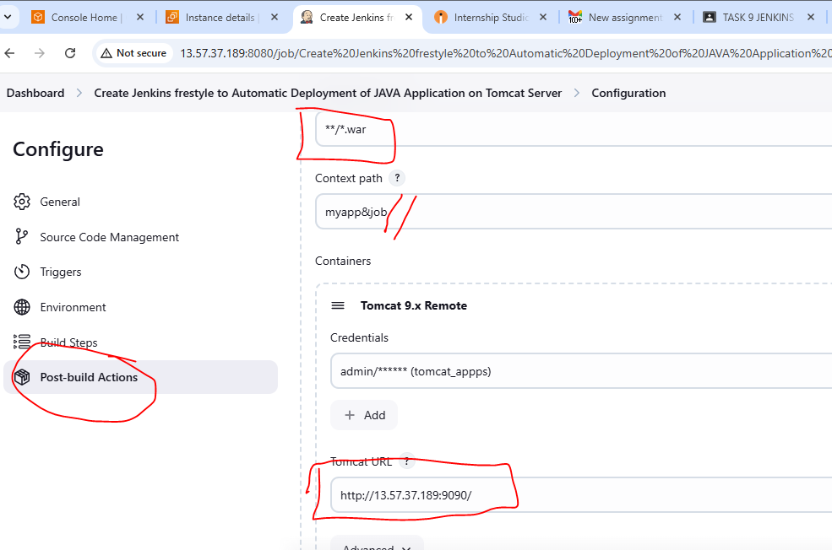

**Output checking:**

**Jenkins console:**

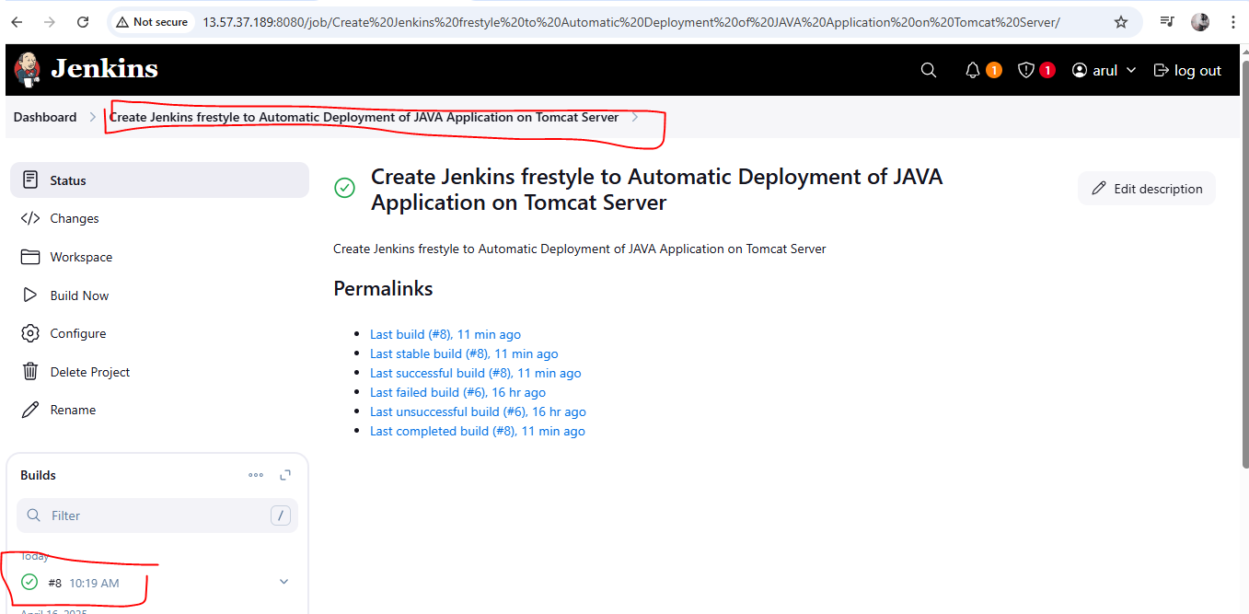

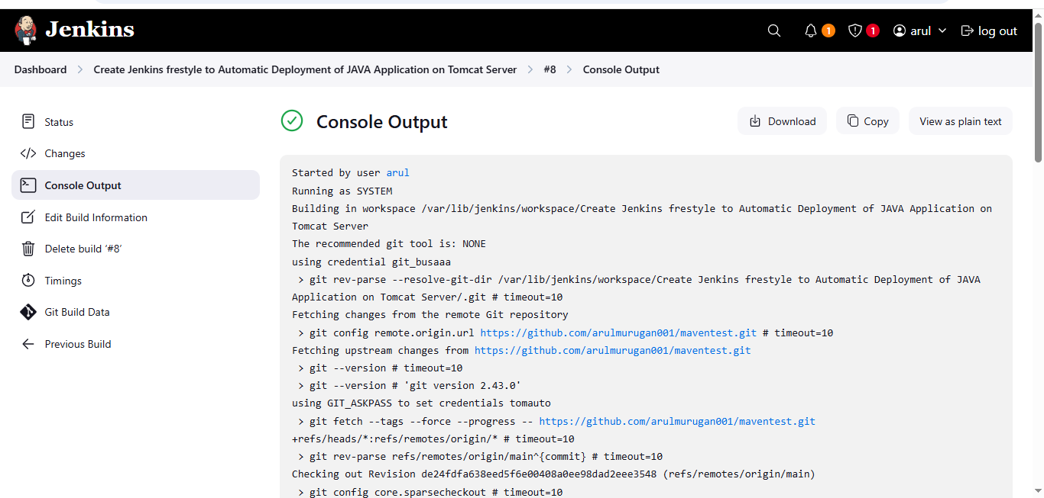

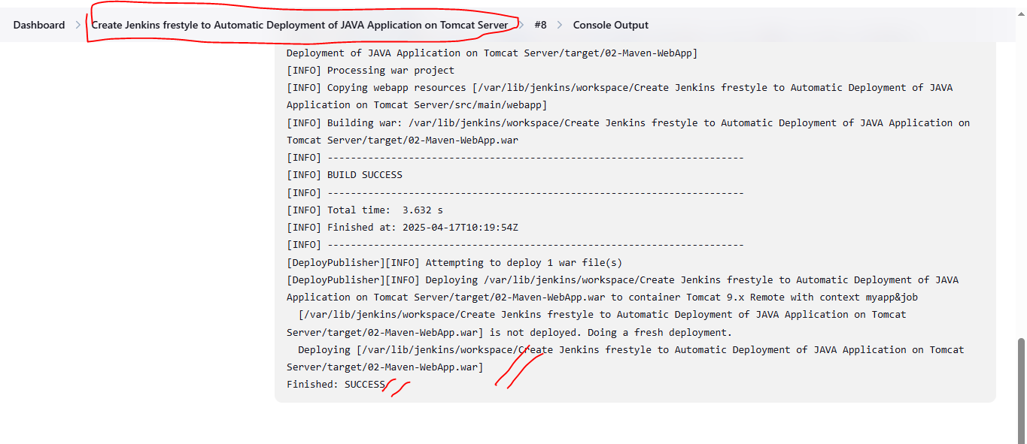

**Deployment file checking:**

**tomcat login:**

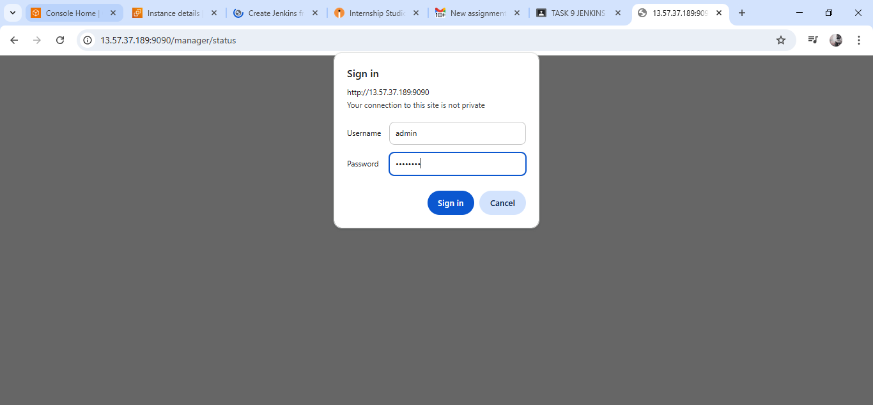

**Got to check the tomcat server:**

**Verify your deployed application ex: /myapp&job**

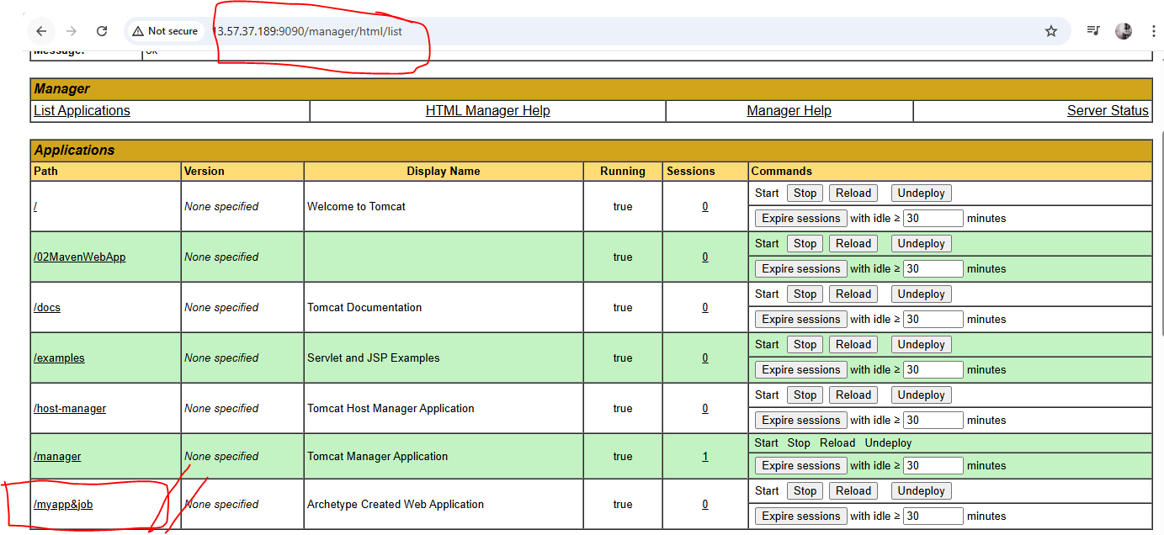

**Content checking**

**Program:**

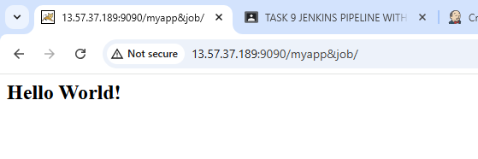

**Program:**

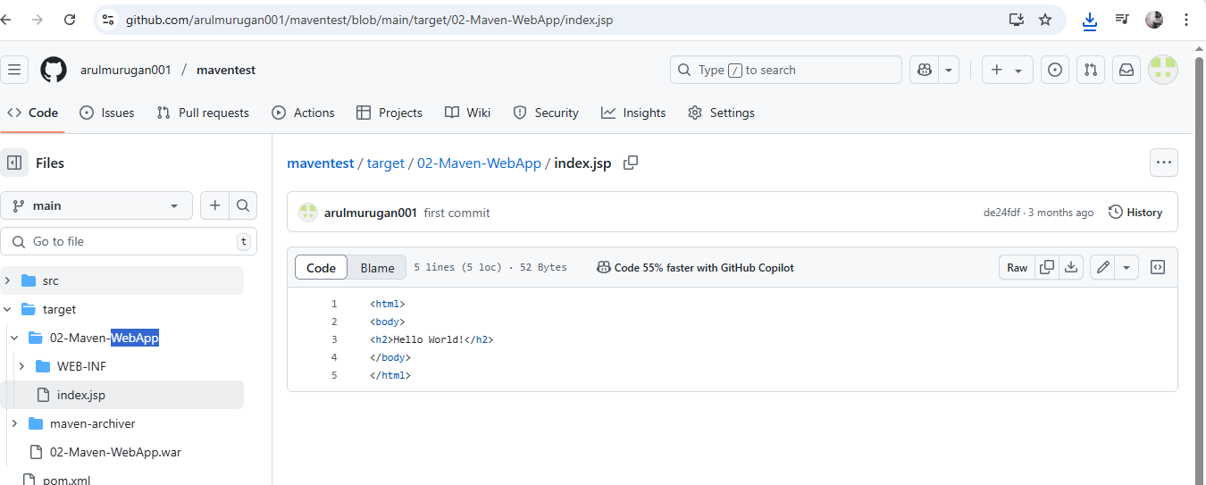

**Githublink:**

**https://github.com/arulmurugan001/maventest.git**